1. Data extraction

I extracted the global data and city data using the below 2 SQL queries:

select * from city_data

select * from global_data

But I then decided to extract the data from the database using the below SQL query because I wanted both global temperature, and my city (Abu Dhabi) temperature to be in the same sheet so that I can plot them together on the same chart using excel, I also used SQL to exclude some data points where data was missing:

SELECT global_data.year , global_data.avg_temp AS global_temp , city_data.avg_temp AS Abu_Dhabi_temp FROM global_data JOIN city_data ON global_data.year = city_data.year WHERE city_data.city = 'Abu Dhabi' AND city_data.avg_temp IS NOT NULL ORDER By global_data.year

1. Data validation

I opened the data files using Excel, I made sure that the number of data points in the raw extracts is equivalent to the number of data points in my SQL query.

1. Data processing

I Opened my data extract CSV with Excel, I calculated the moving average using 10 years span, so for each year; I took the average of temperature of that year along with its previous 9 years as below:

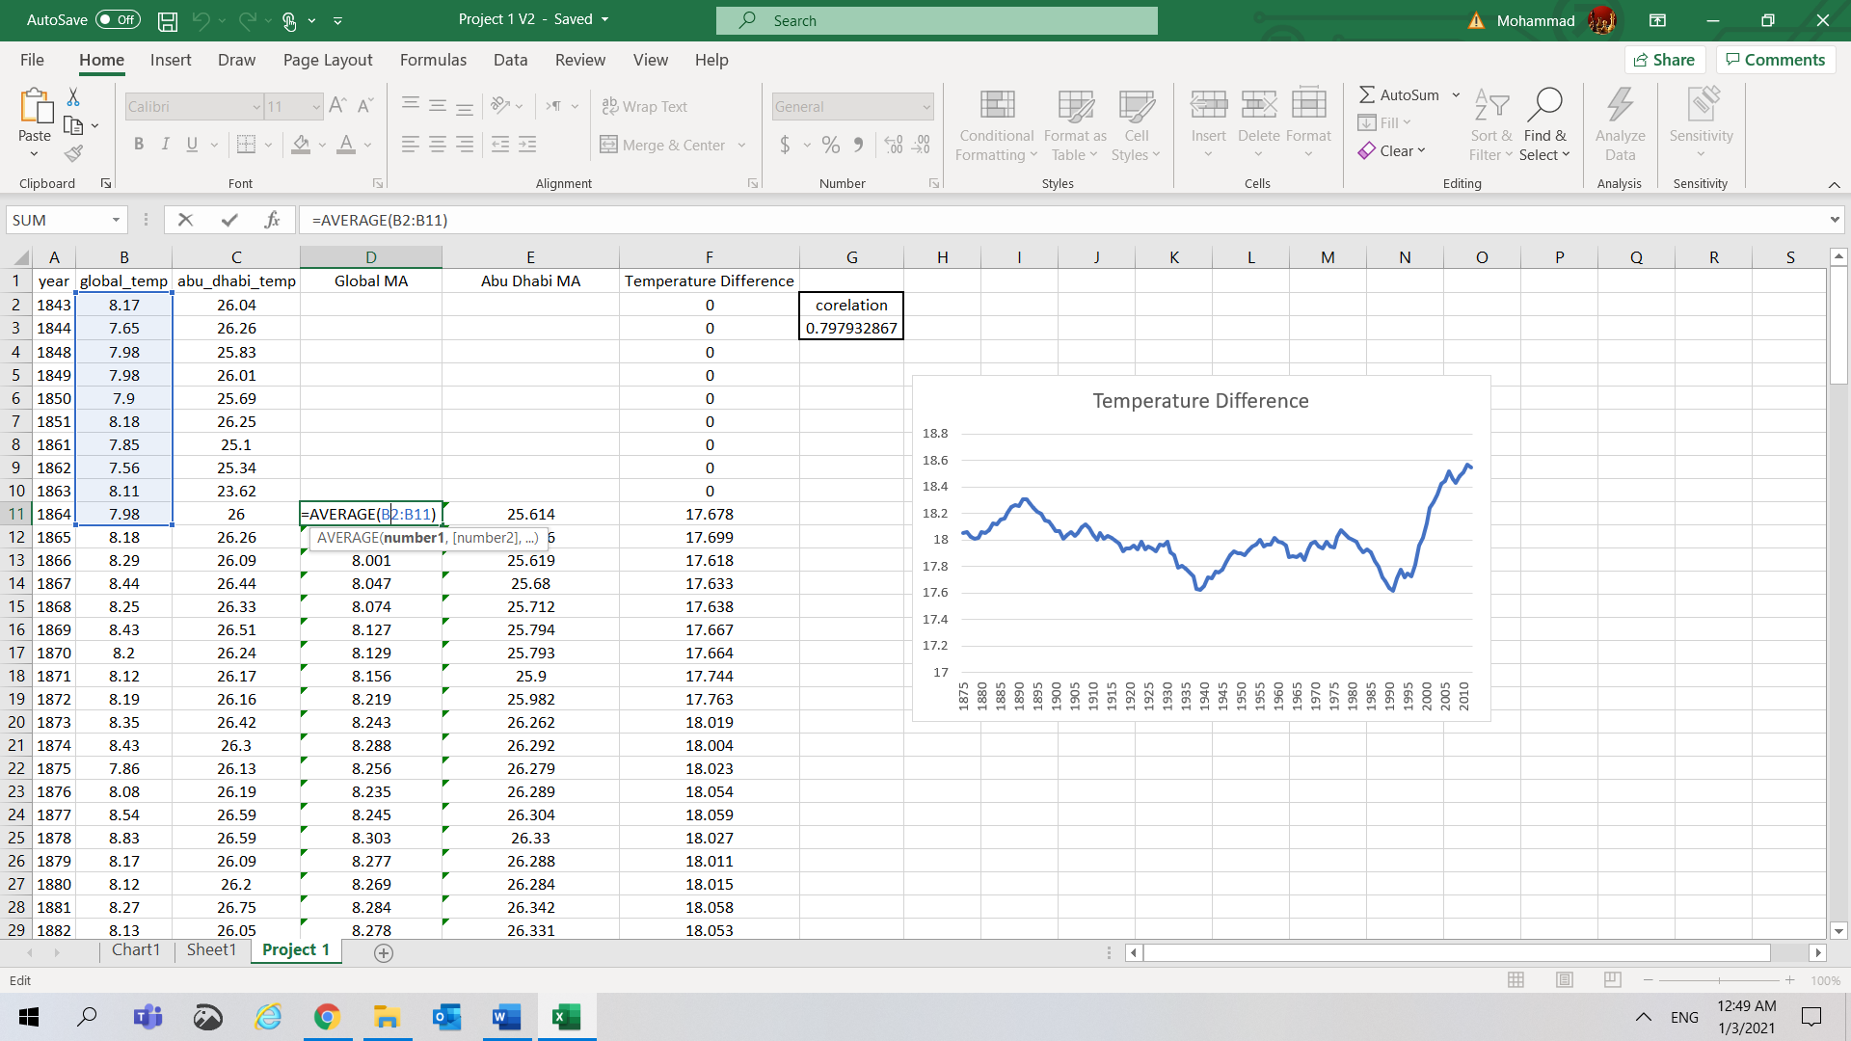

1. Data visualization

I used Excel pivot chart to plot the data, my main considerations on the visualization method were:

1. I wanted both trends to be on the same graph to avoid switching between graphs and have an easier way to compare.
2. I placed years on the X axis to be able to see the trend from past to present.
3. I placed each temperature on a different Y access because of the temperature big difference.
4. I used line charts as other charts made it harder to conclude

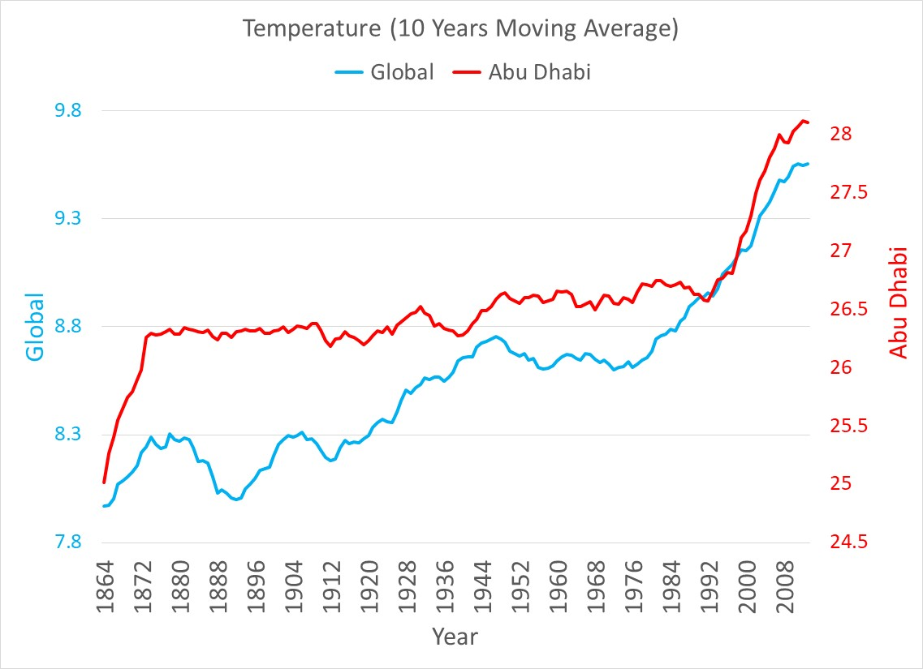

1. Observations
2. My city is hotter than the global by around 18 degrees.
3. This difference is consistent over time.
4. Changes on temperature for both my city and the globe tend to walk hand in hand, this is clear in the increase of temperature for both in 1924, 1937, and 1992. We can ignore the weird dip in my city temperature in the period from 1850 to 1860 as it is caused by missing data.
5. Both my city and global temperatures are raising consistently over time, the world and my city are getting hotter.
6. The trend is consistently raising with only few years where we have dips, this might be caused by specific events in these years like world wars or global economic recessions which affect the pollution and impact global warming (detailed study needs to be done)
7. Extra Analysis
8. I used the Excel function (CORREL) to calculate the correlation coefficient between global and local temperature in my city it came out equal to 0.79 which indicate a strong positive correlation confirming observation number 3 above.
9. It will be easy to estimate temperature in my city based on the global one, it is simply higher by around 18 degrees.

